Triangular Orthobicupola

Definition
# Source: AI Source: Provided by: [Data Path: Persons Table -> ID Column: 1, Name_En Column: Motasem Essam] -> From: [ChatGPT] on [7/25/2026]
A Triangular Orthobicupola is a convex polyhedron formed by joining two identical triangular cupolas at their hexagonal bases, with both cupolas arranged in the same orientation.
It consists of:
- Two opposite equilateral triangular faces.
- Eight equilateral triangular lateral faces.
- Six square lateral faces.
The two hexagonal bases are joined internally and do not appear as external faces.
The Triangular Orthobicupola is the 27th Johnson solid (J27). It is also known as the Anticuboctahedron or Twisted Cuboctahedron.

Geometric Structure
# Source: AI Source: Provided by: [Data Path: Persons Table -> ID Column: 1, Name_En Column: Motasem Essam] -> From: [ChatGPT] on [7/25/2026]
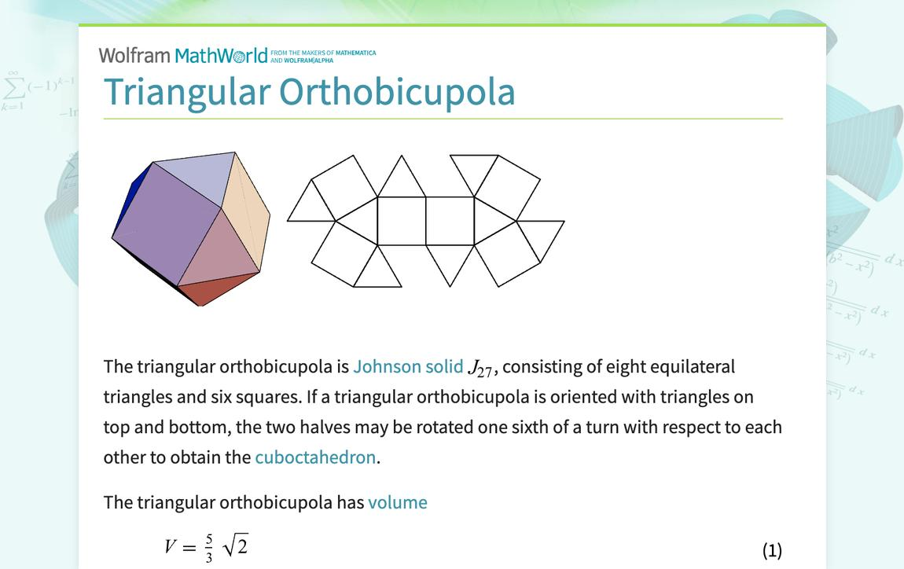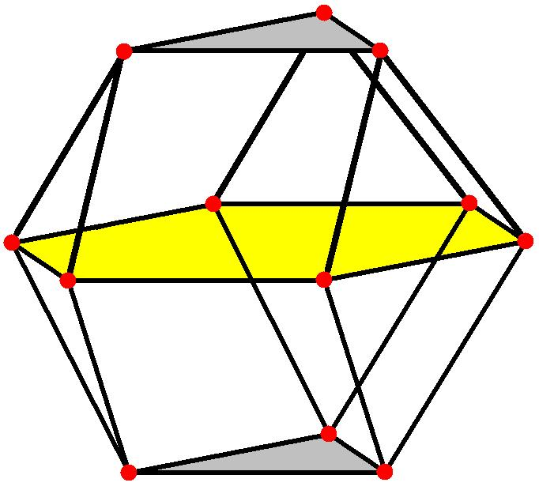
Its main elements are:
- Upper Triangular Face: The upper equilateral triangular face.
- Lower Triangular Face: The lower equilateral triangular face.
- Upper Triangular Cupola: The upper component of the solid.
- Lower Triangular Cupola: The lower component of the solid.
- Triangular Faces: Eight external equilateral triangular faces.
- Square Faces: Six external square faces.
- Central Joining Region: The internal hexagonal region connecting the two cupolas.
- Vertices: Twelve vertices where the edges meet.
- Edges: Twenty-four edges forming the boundaries of the faces.
- Height: The perpendicular distance between the two opposite triangular faces.

Face Composition
# Source: AI Source: Provided by: [Data Path: Persons Table -> ID Column: 1, Name_En Column: Motasem Essam] -> From: [ChatGPT] on [7/25/2026]
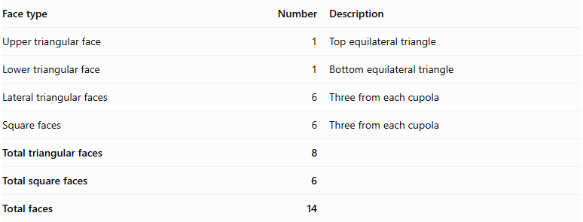
Face type | Number | Description
Upper triangular face | 1 | Top equilateral triangle
Lower triangular face | 1 | Bottom equilateral triangle
Lateral triangular faces | 6 | Three from each cupola
Square faces | 6 | Three from each cupola
Total triangular faces | 8
Total square faces | 6
Total faces | 14

Mathematical Properties
# Source: AI Source: Provided by: [Data Path: Persons Table -> ID Column: 1, Name_En Column: Motasem Essam] -> From: [ChatGPT] on [7/25/2026]
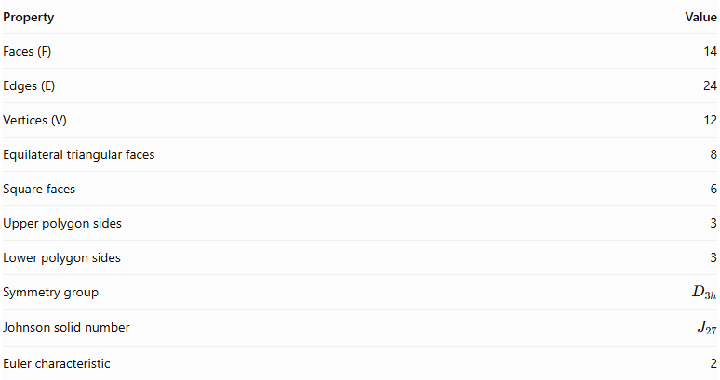
Property | Value
Faces (F) | 14
Edges (E) | 24
Vertices (V) | 12
Equilateral triangular faces | 8
Square faces | 6
Upper polygon sides | 3
Lower polygon sides | 3
Symmetry group | $$D_{3h}$$
Johnson solid number | $$J_{27}$$
Euler characteristic | 2
Euler's Formula:
$$V-E+F=2$$
$$12-24+14=2$$

Vertex Configuration
# Source: AI Source: Provided by: [Data Path: Persons Table -> ID Column: 1, Name_En Column: Motasem Essam] -> From: [ChatGPT] on [7/25/2026]
The solid has two different vertex configurations:
- Six vertices with configuration $3^{2}$.
- Six vertices with configuration $3.4.3.4$.
Here, 3 represents a triangular face and 4 represents a square face. The notation describes the faces surrounding each vertex in cyclic order.

Surface Area
# Source: AI Source: Provided by: [Data Path: Persons Table -> ID Column: 1, Name_En Column: Motasem Essam] -> From: [ChatGPT] on [7/25/2026]
For an edge length $a$, assuming all faces are regular:
$$S=8(\frac{\sqrt{3}}{4}a^{2})+6a^{2}$$
$$\boxed{S=(6+2\sqrt{3})a^{2}}$$

Volume
# Source: AI Source: Provided by: [Data Path: Persons Table -> ID Column: 1, Name_En Column: Motasem Essam] -> From: [ChatGPT] on [7/25/2026]
For a regular Triangular Orthobicupola with edge length $a$:
$$\boxed{V=\frac{5\sqrt{2}}{3}a^{3}}$$

Height
# Source: AI Source: Provided by: [Data Path: Persons Table -> ID Column: 1, Name_En Column: Motasem Essam] -> From: [ChatGPT] on [7/25/2026]
The perpendicular distance between the two opposite triangular faces is:
$$\boxed{h=\sqrt{\frac{8}{3}},a}$$
The volume and height formulas use the regular Johnson-solid construction.

Geometric Characteristics
# Source: AI Source: Provided by: [Data Path: Persons Table -> ID Column: 1, Name_En Column: Motasem Essam] -> From: [ChatGPT] on [7/25/2026]
- It is constructed from two identical triangular cupolas.
- The two cupolas are joined at their hexagonal bases.
- Their triangular faces and square faces have aligned orientations.
- It has two opposite equilateral triangular faces.
- It has eight equilateral triangular faces in total.
- It has six square faces.
- It has 14 external faces.
- It has 24 edges.
- It has 12 vertices.
- It is a convex polyhedron.
- It has dihedral symmetry $D_{3h}$.
- It is not vertex-transitive because it has two different vertex configurations.

Construction of a Triangular Orthobicupola

Geometric Instruments Used
# Source: AI Source: Provided by: [Data Path: Persons Table -> ID Column: 1, Name_En Column: Motasem Essam] -> From: [ChatGPT] on [7/25/2026]
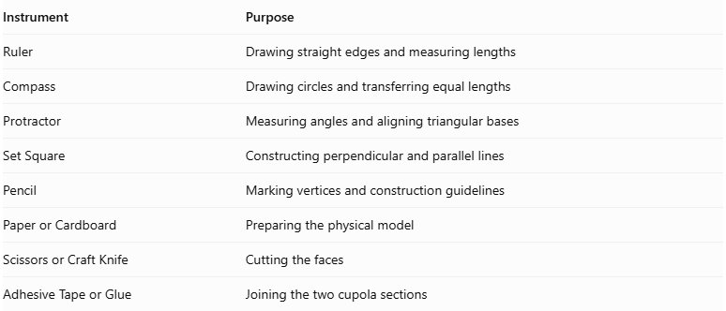
Instrument | Purpose
Ruler | Drawing straight edges and measuring lengths
Compass | Drawing circles and transferring equal lengths
Protractor | Measuring angles and aligning triangular bases
Set Square | Constructing perpendicular and parallel lines
Pencil | Marking vertices and construction guidelines
Paper or Cardboard | Preparing the physical model
Scissors or Craft Knife | Cutting the faces
Adhesive Tape or Glue | Joining the two cupola sections

Instrument-Based Construction Procedures

Constructing the First Triangular Cupola
# Source: AI Source: Provided by: [Data Path: Persons Table -> ID Column: 1, Name_En Column: Motasem Essam] -> From: [ChatGPT] on [7/25/2026]
- Select the common edge length $a$.
- Construct a regular hexagon with side length $a$.
- Construct an equilateral triangle with side length $a$, parallel to the hexagonal base.
- Arrange the triangular base and hexagonal base according to the triangular cupola structure.
- Construct three equilateral triangular lateral faces.
- Construct three square lateral faces.
- Check that the faces have matching edge lengths and correct adjacency.

Constructing the Second Triangular Cupola
# Source: AI Source: Provided by: [Data Path: Persons Table -> ID Column: 1, Name_En Column: Motasem Essam] -> From: [ChatGPT] on [7/25/2026]
- Construct a second triangular cupola with the same dimensions.
- Use a congruent regular hexagonal joining base.
- Construct the second equilateral triangular end base.
- Preserve the same triangular and square face arrangement.
- Verify that the corresponding hexagonal edges match those of the first cupola.

Aligning the Two Cupolas
# Source: AI Source: Provided by: [Data Path: Persons Table -> ID Column: 1, Name_En Column: Motasem Essam] -> From: [ChatGPT] on [7/25/2026]
- Position the two hexagonal bases opposite each other.
- Align their corresponding hexagonal vertices and edges.
- Orient the cupolas so that their square faces meet edge-to-edge around the joining region.
- Ensure that the two triangular end bases have the same rotational orientation.
- Check that the arrangement is orthobicupola rather than gyrobicupola.

Joining the Cupolas
# Source: AI Source: Provided by: [Data Path: Persons Table -> ID Column: 1, Name_En Column: Motasem Essam] -> From: [ChatGPT] on [7/25/2026]
- Bring the two hexagonal bases together.
- Match all six corresponding edges.
- Join the cupolas along the shared hexagonal base.
- Treat the hexagon as an internal joining face.
- Preserve the two equilateral triangular bases as the external end faces.
- Verify that the six square and six lateral triangular faces are correctly connected.

Completing the Solid Drawing
# Source: AI Source: Provided by: [Data Path: Persons Table -> ID Column: 1, Name_En Column: Motasem Essam] -> From: [ChatGPT] on [7/25/2026]
- Draw the two triangular end bases.
- Draw the six lateral triangular faces.
- Draw the six square faces.
- Represent the shared hexagonal joining region as internal rather than external.
- Draw visible edges using continuous lines.
- Draw hidden edges using dashed lines where appropriate.
- Inspect the completed solid for symmetry and correct face adjacency.

Related Geometric Solids
# Source: AI Source: Provided by: [Data Path: Persons Table -> ID Column: 1, Name_En Column: Motasem Essam] -> From: [ChatGPT] on [7/25/2026]
- Triangular Cupola
- Triangular Gyrobicupola
- Square Orthobicupola
- Pentagonal Orthobicupola
- Cuboctahedron
- Elongated Triangular Orthobicupola
- Trapezo-Rhombic Dodecahedron (Dual Polyhedron)
Important distinction: The Triangular Gyrobicupola is the Cuboctahedron, whereas the Triangular Orthobicupola is a different solid with a different relative orientation of its two cupolas.

Main Classification
# Source: AI Source: Provided by: [Data Path: Persons Table -> ID Column: 1, Name_En Column: Motasem Essam] -> From: [ChatGPT] on [7/25/2026]
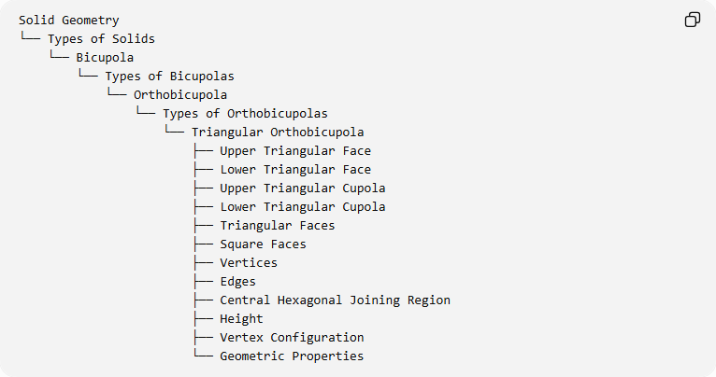
Solid Geometry
└── Types of Solids
└── Bicupola
└── Types of Bicupolas
└── Orthobicupola
└── Types of Orthobicupolas
└── Triangular Orthobicupola
├── Upper Triangular Face
├── Lower Triangular Face
├── Upper Triangular Cupola
├── Lower Triangular Cupola
├── Triangular Faces
├── Square Faces
├── Vertices
├── Edges
├── Central Hexagonal Joining Region
├── Height
├── Vertex Configuration
└── Geometric Properties

Key Points
# Source: AI Source: Provided by: [Data Path: Persons Table -> ID Column: 1, Name_En Column: Motasem Essam] -> From: [ChatGPT] on [7/25/2026]
- The Triangular Orthobicupola is Johnson solid $J_{27}$.
- It is formed by joining two triangular cupolas at their hexagonal bases.
- It has 8 equilateral triangular faces and 6 square faces.
- It contains 14 faces, 24 edges, and 12 vertices.
- Its two cupolas have aligned orientations.
- It is also known as the Anticuboctahedron or Twisted Cuboctahedron.

Conclusion
# Source: AI Source: Provided by: [Data Path: Persons Table -> ID Column: 1, Name_En Column: Motasem Essam] -> From: [ChatGPT] on [7/25/2026]
The Triangular Orthobicupola is a convex Johnson solid constructed by joining two triangular cupolas in an orthogonal face arrangement. Its distinctive structure consists of eight equilateral triangles and six squares, making it a useful example of a composite polyhedron formed from two cupolas.

